Python Exceptions –

Try and Except Statement – Catching Exceptions

n Python, we catch exceptions and handle them using try and except code blocks. The try clause contains the code that can raise an exception, while the except clause contains the code lines that handle the exception

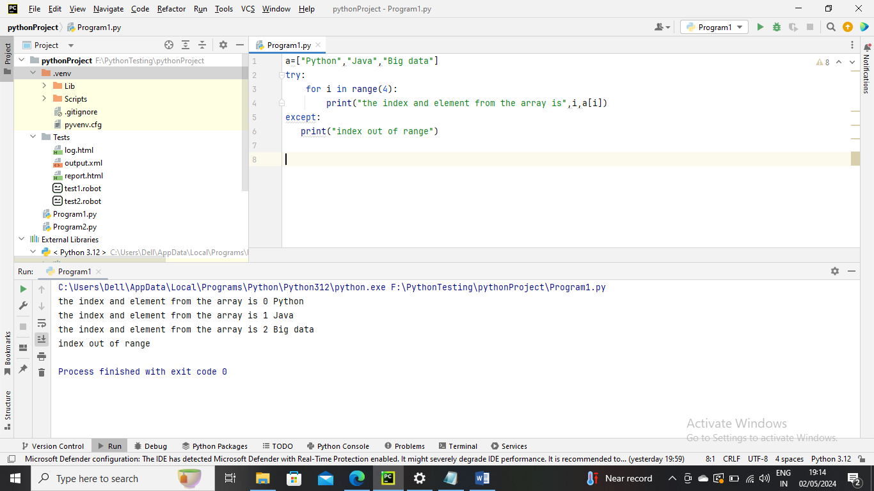

How to raise an exception

If a condition does not meet our criteria but is correct according to Python interpreter, we can intentionally raise an exception using the raise keyword

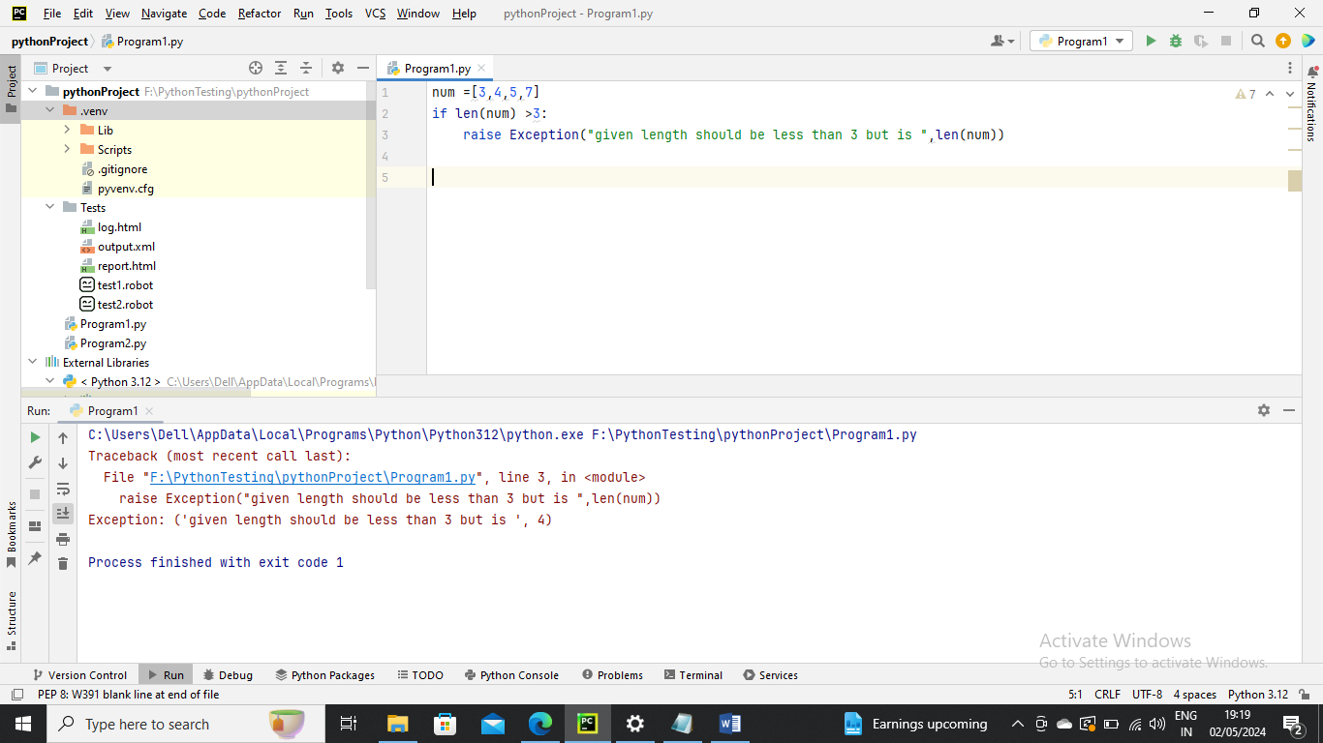

Assertions in Python

An assertion is a consistency test that we can switch on or off

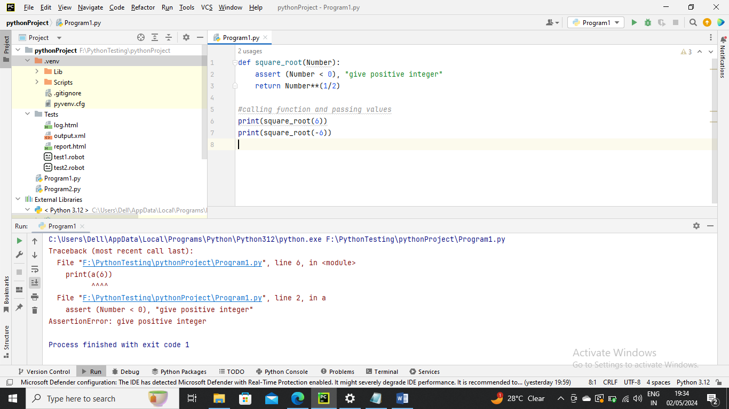

Try and Except with else clause –

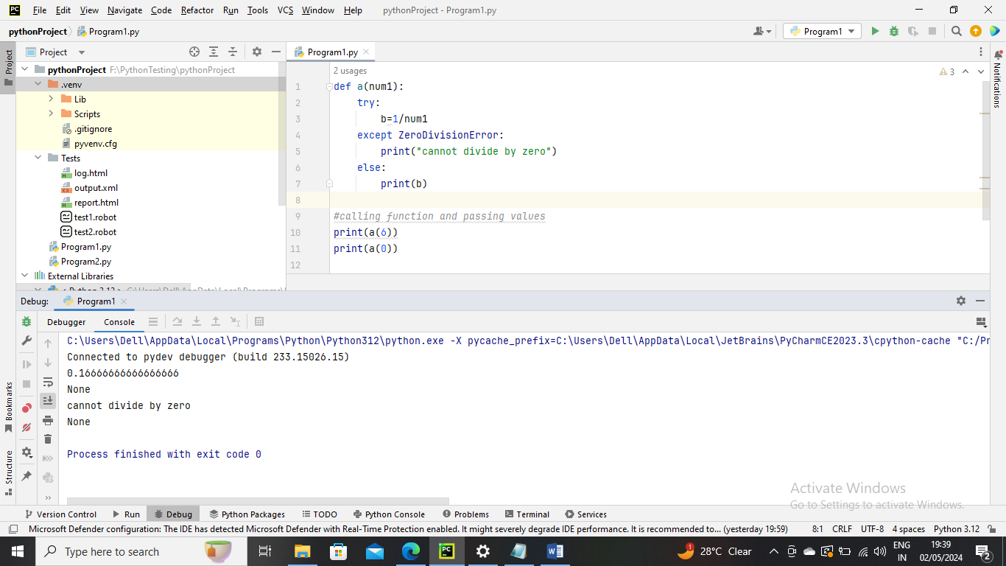

Finally Keyword –

The finally code block always executed after the try block has terminated normally or after the try block has terminated for some other reason

The Finally block will execute no matter what if it comes into try block

